1. t2oli el feilds bat3t el order

full name

address

city

zip

mobile

email

order notes

1. 2- el sidebar bat3 el checkout hyt7t feh eh ?

Same as products , order, checkput pages ( products category list – latest 2 blog art)

1. 3-eh el reports ely 3yzha f el dashbaord ll orders

Order request table ( showing name-all order total amount – full name – status) when click on order -> ( show all customer info and order details )

Reports page -> filter by date ( showing - how many order placed - top item selling- total amount per date on filter)

1. 4- index page eh el sections ely feha b el tfseeeel

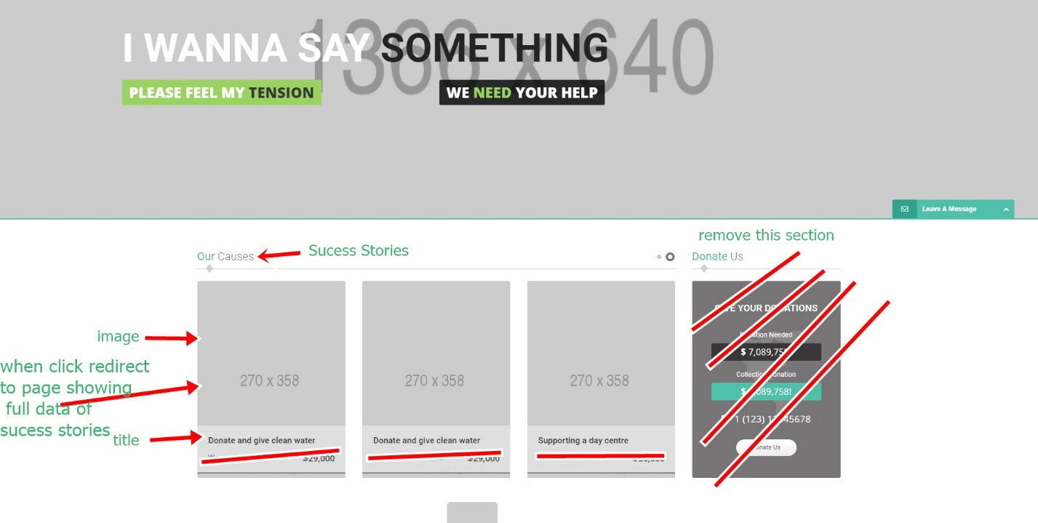

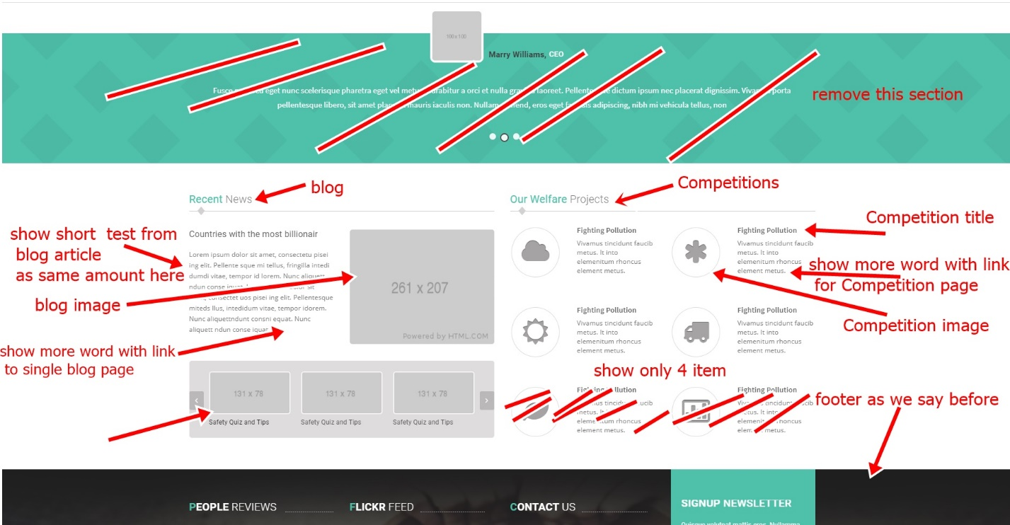

1. 5- esm el user ely 3aml login hyzhr feeen w shklo ezaaay ?

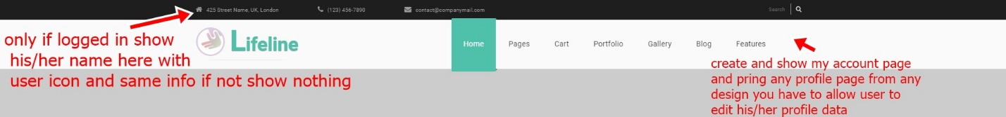

1. eh El search Eli ashelo w eh Eli akhleh

home page search ( search for products ) and every side par search for the same topic of the page it belong

1. 7-t2oli bs kol search hy3ml search f eh

Same as NO 6

1. 8- fen El page Eli htl3 feha search results

Search will be with auto complete so when user click on results will redirect him to the single page-product-blog-etc

